**University Of New Mexico US Passport Application Acceptance Facility**

The University of New Mexico has an authorized U.S. Government Passport Acceptance Facility in the UNM Bookstore serving the entire Albuquerque community.

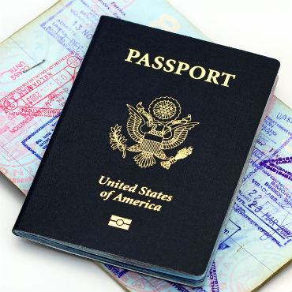

*(This would be a picture of a Lobo Louie “Get your US Passport at the Bookstore!”)*

**APPLICATION PROCEDURES**

Click this link for information on how to apply for your passport.

<https://travel.state.gov/content/travel/en.html>

**HOURS AND LOCATION**

APPOINTMENTS ACCEPTED

Tuesday through Friday: 11:15 AM - 1:00 PM

<Click here to make appointment>

WALK-IN SERVICE

Tuesday, Thursday, Friday: 4:00 PM - 6:00 PM

Saturday: 11:00 AM – 3:00 PM

* Walk-in applications are taken on a first come first serve basis.

**DIRECTIONS**

LOCATION

The UNM bookstore is located at 2301 Central Ave NE Albuquerque New Mexico 87131

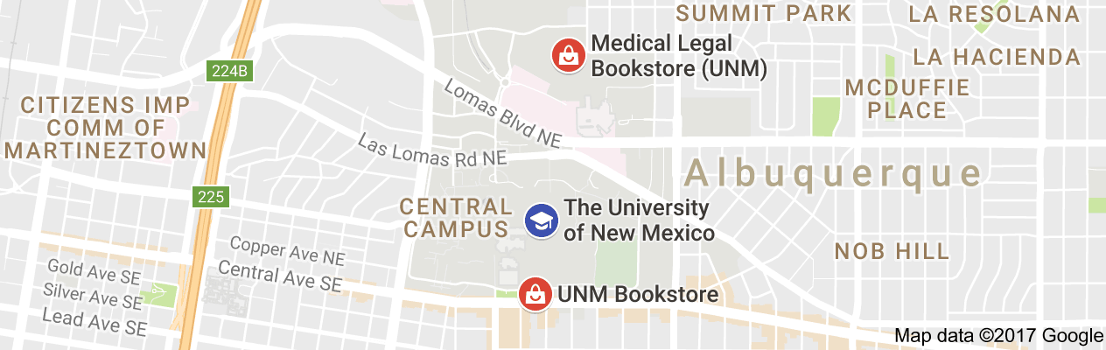

PARKING

Parking is available at the Cornell parking structure at the rate of $1.00 per half hour.

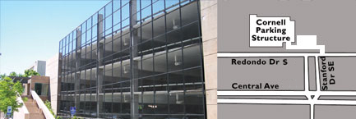

**GET YOUR PASSPORT**

Here is what you need to know

1. Applicants for passports must be U. S. Citizens.
2. All applicants must appear in person.
3. Both parents must appear in person for minors under the age of 16.

**PASSPORT FEES**

**NOTE: THERE ARE TWO SEPARATE PAYMENTS - NO CASH ACCEPTED**

1. **PASSPORT APPLICATION FEE 2. EXECUTION FEE- $25.00**

-Must be paid with check or money order - Can be paid with check, money

-Make check or money order payable to order, debit or credit cards,

"U.S. Department of State" MasterCard or Visa

-Temporary or starter checks are - Make check or money order out to

not accepted University of New Mexico

Click here for the full Passport Fees Chart

<https://ibp.nmsu.edu/files/2016/06/Passport-Fees-Chart_june2016.pdf>

**PHOTOS**

$15.00 to use our passport photo service. Fee can be paid with check, money order, debit or credit card.

**COPIES**

We can make copies of your documents for you for $1 per copy- NO CASH ACCEPTED.



**DOCUMENTS REQUIRED**

PROOF OF CITIZENSHIP

* Certified birth certificate from the country or state where you were born.

Click here for information on obtaining your New Mexico birth certificate.

<https://nmhealth.org/about/erd/bvrhs/vrp/birth/>

* A Naturalization certificate
* Certificate of citizenship
* A valid passport book or card

PROOF OF IDENTITY

* A valid state or federally issued picture ID such as a driver’s license, ID card, military ID, passport book or card.

**FORMS REQUIRED**

DS-11 FORM

* DS-11 form- <https://www.state.gov/documents/organization/212239.pdf>
* IF you are printing your DS-11 at home please ensure that the form prints on two separate pages, not front and back.

WHAT YOU NEED TO HAVE

* Proof of citizenship
* Proof of identity- Provide photocopy of front and back of ID
* Two 2X2 passport photos
* Passport application fee
* Execution fee
* DS-11 form

**PROCESSING TIME**

Routine processing takes 4-6 weeks from the application date.

Expedited processing takes approximately 2-3 weeks from the application date. Additional fees apply.

**CAN YOU RENEW YOUR PASSPORT BY MAIL?**

<https://travel.state.gov/content/travel/en.html>

**CONTACT INFO**

PHONE: (505)

E-MAIL:

WEBSITE: passport.unm.edu